**4 - ServiceNow Branding Overview**

**Branding** - Branding in ServiceNow lets us customize the workspace to match our company's identity. This includes applying our corporate logo, fonts, and other branding elements to the Now Platform UI to create a consistent look, build trust, and encourage adoption.

**Guided Setup -** Guided Setup gives system admins step-by-step instructions to configure various applications and modules to meet user needs. It helps plan the product roll out and perform the basic setup to go live. Access it via the Application Navigator by selecting ITSM Guided Setup or ITOM Guided Setup.

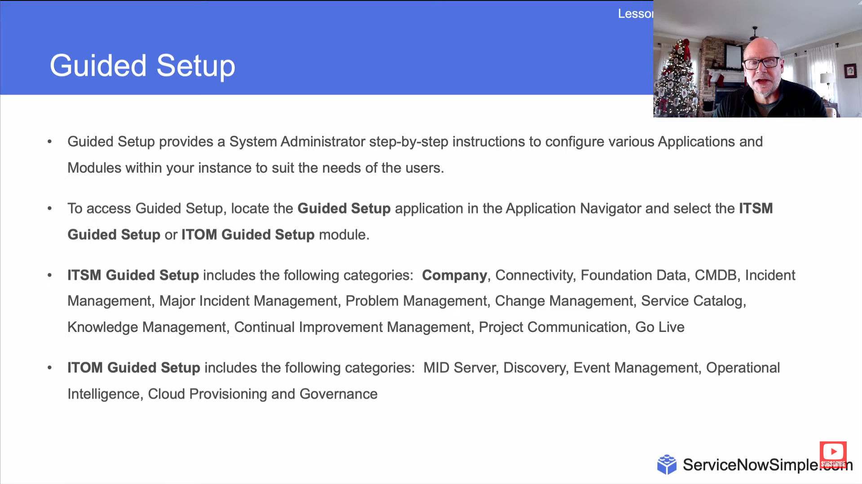

**ServiceNow Portal -** This widget-based tool allows for creating intuitive and user-friendly interfaces for the Now Platform.

**UI Builder -** UI Builder lets you create functional pages by selecting from a library of components and layouts.

ANANYA CHOUDHARY